Testing Manual

  - Active Brains
  - Version 1.4 12/09/18

Getting Started
Testing an intervention is not like using the website. When testing the intervention we are systematically looking for way to break the website. It's very important to record how you used the website to break it, so that the person fixing it has enough information to know what went wrong.

Do
- Keep a note of the TIME you sign-up and log-in as a new/old user
- Make a note of the TIME the error occurred
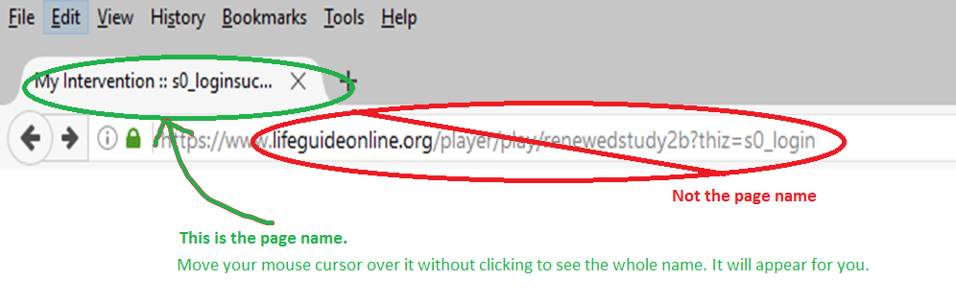
- Make a note of the PAGE NAME the error occurred on – the page name is the name in the TAB on your browser, not the title on the page or the web link in the address bar.
- If the PAGE NAME is 'Active Brains', make a note of the URL in the address bar instead
- Make a note of the USERNAME and PASSWORD that you use – but don't use your own!
  - It's a good idea to annotate the username with your initials, the time you signed up and attributes of the test e.g. kas14153004highpa (14:15 on 30/04 for a user with high physical activity)
- Create some testing email addresses using Gmail or Hotmail when you are testing emails.
- Record all users you create, even if you don't find any errors
- Use different browsers and platforms – but record this (e.g. chrome, safari, smartphone, tablet – please make note of the browser version, usually found in settings>about in the browser menu)
- Record errors in as much detail as you can – you can use snipping tool to make easy screenshots
- Record the name of the intervention you are testing e.g. www.lifeguideonline.org/player/play/recontest300418

Don't
- Use a fake email address (if the intervention has emails in it)
- Use your primary email address
- Enter your personal details – make up fake details e.g. 123 Example Street
- Forget to make note of the time
- Miss out trivial errors

Intervention details
Below are the details for the intervention to test.
Intervention name: shortname of intervention
Intervention link: XXXXXX
Testing Googledoc: XXXXX

To access the intervention:
- Type a username
- Type an email address
- Type a password
  - NOTE: this is also the login page. Just type in the same username, email and password you used to sign up.
- Click Log In
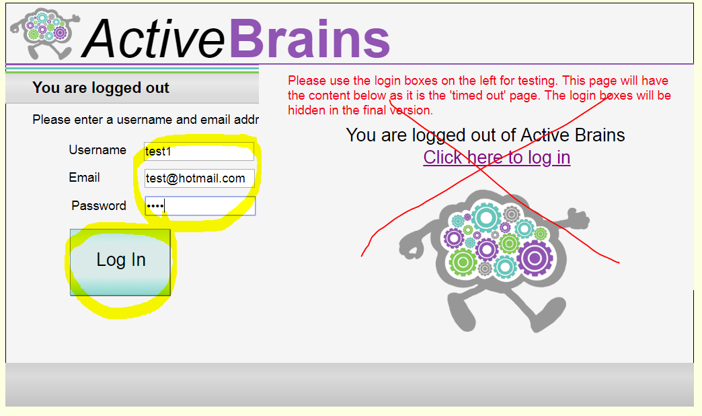
- Click 'Next' on each page until you reach the Active Lives Homepage.
- Close your web browser or switch to a different web browser and re-open the website.
- Login in again using the same details you used to sign up.
- Click Next after the page titled 'Welcome'

Notes
- There are emails in this intervention
- The timings have been speeded up to 1 day = 5 seconds – this affects when things unlock, when goals are available to review, and when emails arrive.
- You do not need to test any page that begins j_TEMP (these are temporary pages)

Summary of testing
The aim of this test iteration is to:
- Check the booster pages work correctly and the content is correct
  - Compare to 'Booster Content Main Pages v4 kas.docx'
- Check the other content is error-free
- Check the goal setting and reviews

Testing Pages
In your first run through the website, create a spreadsheet like this. This will help you keep track of the pages you have tested:
Date: 01/05/18 | Device: Android Smartphone | Browser: Chrome 64.0.3282.123
Page name | Tested | Errors
S_p1_examplepage | Yes | None
S_p2_examplepage

For each page, complete the following checklist. You might want to print this off so you can see it as you look at the page:
Checklist for every page
Error | OK/Yes
Page flow and usability issues
☐ | ☐ | Do you know where to go next?  Is there sign-posting to tell you where to go/is it obvious what options are available?
☐ | ☐ | Can you see where to click to move on?  Are you told/is it obvious where to click to view a different page.
☐ | ☐ | When you click on something, do you end up where you expected to be?  When you click a link, does it take you to the page that you expected it to take you to? Do you think you have 'got lost' somewhere?
☐ | ☐ | Can you tell that you have progressed after you click?  Does the page change to a new page after you click? Does it take too long or require another click?
Page content and format issues
☐ | ☐ | Are there any typos or spelling errors?
☐ | ☐ | Are there any inconsistencies in formatting (e.g. different use of capitals, changes in positioning of things on page, overlapping text in boxes, text being cut off the page)?
☐ | ☐ | Does a print button (if applicable) actually work?
☐ | ☐ | Is the printed page correctly formatted?  (if hard to describe, please make a screenshot, e.g. with snipping tool from windows start menu)
☐ | ☐ | Do you get an error message if you don’t give an answer to a question?  (please do not type any answers/select any options and try to proceed – error messages should usually be displayed)
☐ | ☐ | Is the error message appropriate?
☐ | ☐ | You should not see any pages that say “you should not see this page”.

If you find ANY ERRORS (including problems with design), please record each one in a new line on the testing google doc as soon as you find it.
If you have access to a different device or web browser, you can repeat this test on a different platform.

Testing Goal Reviews

- For each section of Active Brains, set 2 goals (1 for Brain Training)
- Wait 35 seconds
- Click on 'My Goals' from the Active Brains Homepage
- Click 'Review my goals'
- Refer to the TestingGoalSetting spreadsheet. You should mark the goals as Totally met (T), Partially met (P) or Not at all met (F) accordingly.
- Copy the text on the screen
- Click on the formula box in the TestingGoalSetting spreadsheet
- Right click and select Paste
- You can click Wrap Text on the Home tab to force if the row in your spreadsheet becomes too tall.
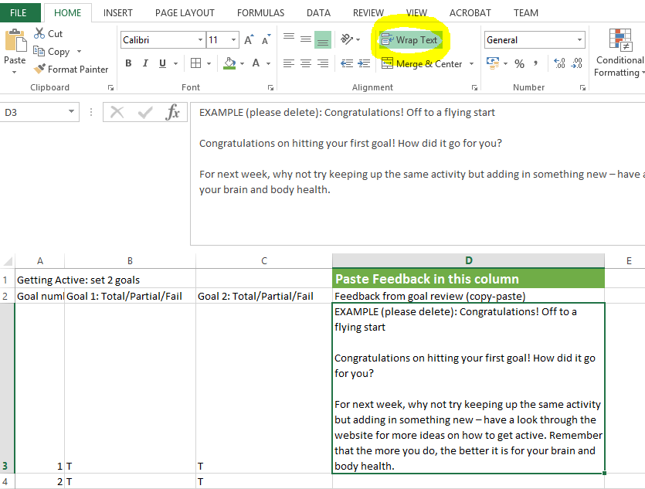
  - If there are any errors in the goal feedback, note them in the testing spreadsheet. Copy-paste the entire goal feedback paragraph into the testing spreadsheet when you do this.
- Set 2 new goals
- Work your way down the spreadsheet providing all goal review combinations detailed.
- Once you have completed the spreadsheet, return it to XXXXX

